SOFTWARE DESIGN SPECIFICATION

FOR #43 RESEARCH PAPER TRACKING AND RECOMMENDTAION TOOL
PREPARED BY – HARITHA NEELA (SE23UMCS046)
VERSION – 1.0
Team members:
HARITHA | SE23UMCS046
YASAWINI | SE23UCSE180
GAYATHRI | SE23UMCS047
PRASAMITA | SE23UMCS048
SWAROOPA | SE23UMCS066
BHUWANESHWARI | SE23UMCS052
JAGRAT | SE23UARI050
SHAHZEB | SE23UCSE197

Document Information:
Title – Research Paper Tracking and Recommendation Tool
Project Manager – Murali Krishna
Prepared by – Haritha
Document version – 1.0
Preparation date – 8th April 2026

Version History:
Ver. No. | Ver. Date | Revised by | Description | Filename

Table of Contents:
- INTRODUCTION
  - PURPOSE
  - SCOPE
  - DEFINITIONS, ACRONYMS, AND ABBREVATIONS
  - REFERENCES

- USE CASE VIEW
  - USE CASE

- DESIGN OVERVIEW
  - DESIGN GOALS AND CONSTRAINTS
  - DESIGN ASSUMPTION
  - SIGNIFICANT DESIGN PACKAGES
  - DEPENDENT EXTERNAL INTERFACES
  - IMPLEMENTED APPLICATION EXTERNAL INTERFACES

- LOGICAL VIEW
  - DESIGN MODEL
  - USE CASE REALIZATION

- DATA VIEW
  - DOMAIN MODEL
  - DATA MODEL
    - DATA DICTIONARY

- EXCEPTION HANDLING

- CONFIGURABLE PARAMETERS

- QUALITY OF SERVICE
  - AVAILABILLITY
  - SECURITY AND AUTHORIZATION
  - LOAD AND PERFORMANCE IMPLICATIONS
  - MONITORING AND CONTROL

1. Introduction
The Software Design Specification (SDS) for the Research Paper Tracking System presents the detailed design of the proposed software system. This document describes the system architecture, design components, module interactions, database structure, user interface design, and internal workflows required for implementing the system successfully.
The SDS serves as a technical blueprint for developers, testers, and project stakeholders by explaining how the system will be constructed to satisfy the functional and non-functional requirements defined in the Software Requirements Specification (SRS). It provides a clear understanding of the software design and acts as a reference during development, testing, and maintenance phases.
1.1 Purpose
The purpose of this Software Design Specification is to define the internal design and technical structure of the Research Paper Tracking System. It explains how the system components are organized, how different modules interact, how data is stored and processed, and how the user interface supports user activities.
This document is intended for use by:
- Developers, for implementing the system design
- Testers, for understanding the system structure during validation
- Project guides and evaluators, for reviewing the design approach
- Future maintainers, for understanding the internal working of the system
This document is expected to be used as a technical reference throughout the software development life cycle.
1.2 Scope
The Software Design Specification applies to the complete design of the Research Paper Tracking System, a web-based application developed to help users search, organize, save, track, and manage research papers efficiently.
The scope of this document includes the design of:
- User authentication and account management
- Research paper search and retrieval module
- Paper details viewing module
- Workspace or saved papers management
- Notes and annotations management
- Reading progress tracking
- AI-based summary and recommendation support
- Database structure and storage design
- User interface and interaction flow
- System architecture and module communication
This document covers the software design aspects required for implementing the system and ensuring that all modules work together effectively.

1.3 Definitions, Acronyms, and Abbreviations
The following terms, acronyms, and abbreviations are used in this document:
- SDS – Software Design Specification
- SRS – Software Requirements Specification
- UML – Unified Modelling Language
- UI – User Interface
- DB – Database
- API – Application Programming Interface
- LLM – Large Language Model
- AI – Artificial Intelligence
- User Authentication – The process of verifying the identity of a user during login or registration
- Workspace – A personalized area where users can save and manage selected research papers
- Reading Progress Tracking – A feature used to monitor the completion status of papers being read by the user
- Recommendation Engine – A module that suggests relevant research papers based on user interests or saved content
- Paper Metadata – Information related to a research paper such as title, author, abstract, keywords, publication year, and source
1.4 References
The following documents and resources were referred to during the preparation of this Software Design Specification:
- Software Requirements Specification (SRS) for the Research Paper Tracking System
- System Requirement and Analysis / Software Engineering course materials
- IEEE Recommended Practice for Software Design Descriptions
- UML Diagrams prepared for the Research Paper Tracking System
- Technical references for the selected implementation technologies such as:
  - Frontend framework documentation
  - Backend framework documentation
  - Database documentation
  - API integration references (if applicable)

2. Use Case View
The Use Case View of the Research Paper Tracking System describes the major interactions between the user and the system. It represents the core functionalities of the system from the user’s perspective and helps in understanding how different modules are designed to support user activities.
This view is based on the functional requirements defined in the Software Requirements Specification (SRS). The primary actor in the system is the User, who interacts with the system to search for research papers, save and organize them, manage notes, track reading progress, and receive AI-supported summaries or recommendations.
The Use Case View provides a design-oriented understanding of the system by identifying the key use cases that influence the internal software design, module structure, and interaction flow. The use case diagram associated with this system illustrates these interactions and serves as a visual representation of the system’s functional behavior.
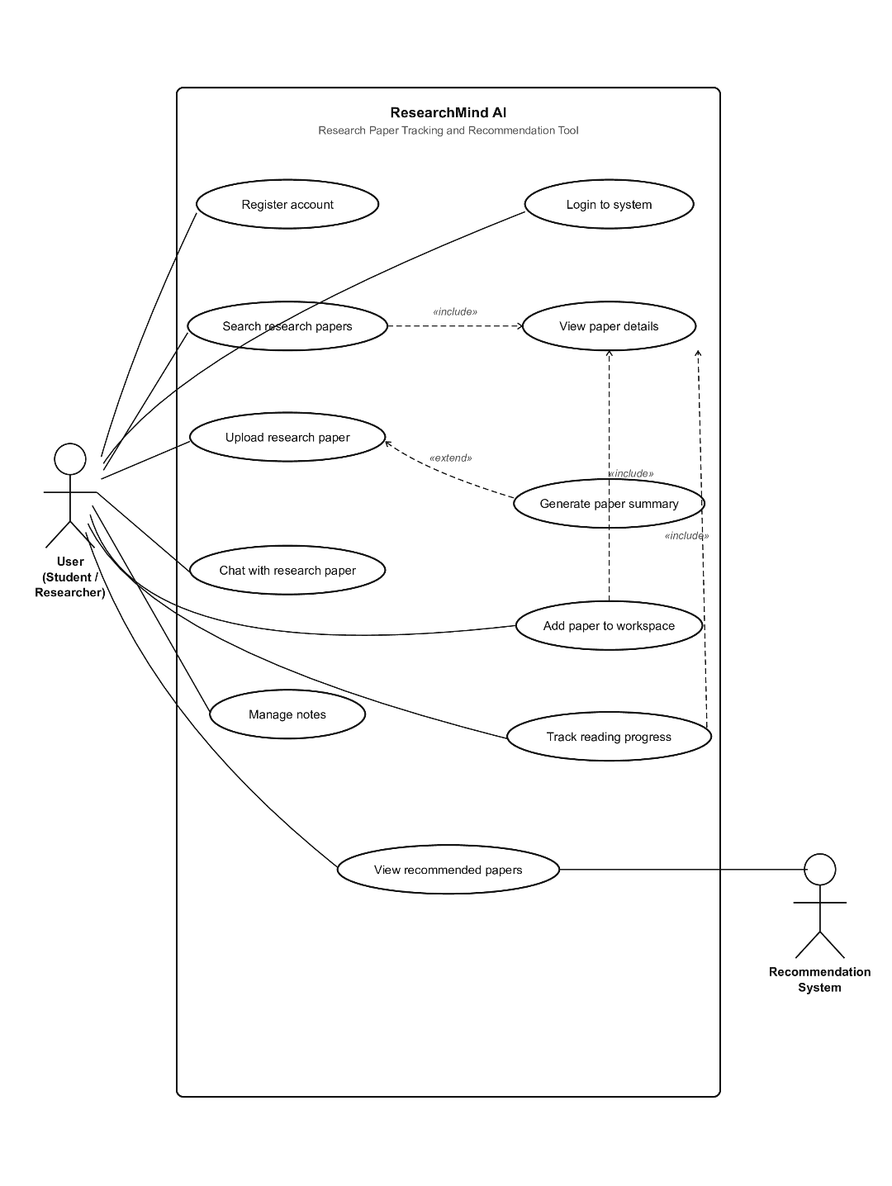
2.1 Use Cases
The following major use cases are considered in the design of the Research Paper Tracking System:
2.1.1 Register Account
Description:
This use case allows a new user to create an account in the system by providing the required registration details.
Actor:
User
Precondition:
The user must not already have an account.
Basic Flow:
- The user opens the registration page.
- The user enters details such as name, email, and password.
- The system validates the entered information.
- The system creates a new user account.
- The user is successfully registered and can log in.
Postcondition:
A new user account is created and stored in the database.
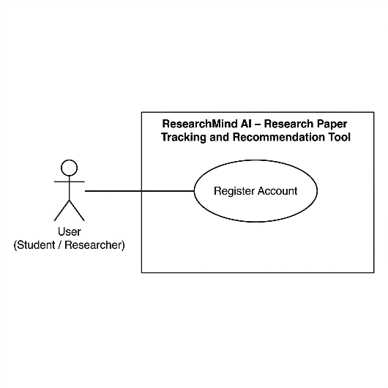
2.1.2 Login to the System
Description:
This use case allows a registered user to access the system securely using login credentials.
Actor:
User
Precondition:
The user must have a valid registered account.
Basic Flow:
- The user opens the login page.
- The user enters email and password.
- The system verifies the credentials.
- If valid, the system grants access to the dashboard.
Postcondition:
The user is authenticated and logged into the system.
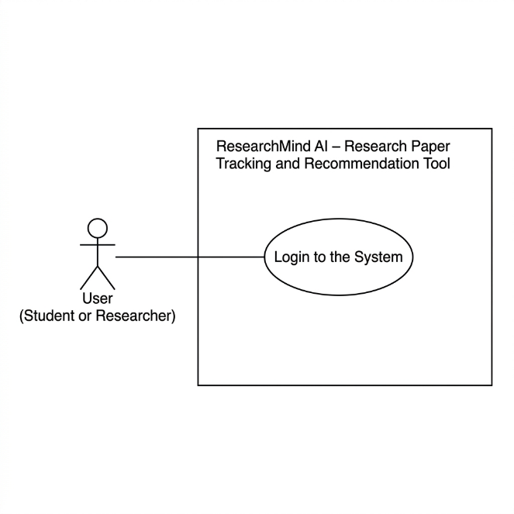
2.1.3 Search Research Papers
Description:
This use case allows the user to search for research papers based on title, keyword, author, or topic.
Actor:
User
Precondition:
The user must be logged into the system.
Basic Flow:
- The user enters a search query.
- The system processes the search request.
- Relevant research papers are retrieved and displayed.
- The user can select a paper for more details.
Postcondition:
A list of relevant research papers is displayed to the user.
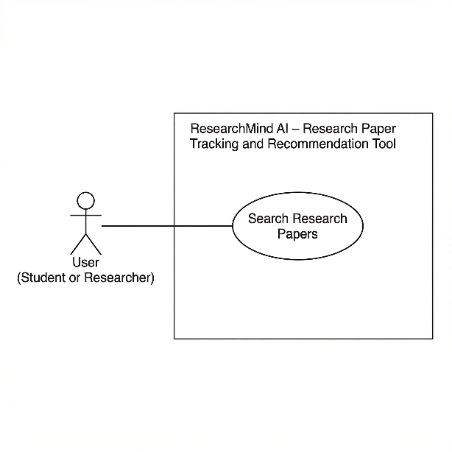
2.1.4 View Paper Details
Description:
This use case enables the user to view detailed information about a selected research paper.
Actor:
User
Precondition:
The user must select a paper from search results or saved workspace.
Basic Flow:
- The user selects a research paper.
- The system displays metadata such as title, authors, abstract, publication year, and source.
- The user can choose to save, summarize, or annotate the paper.
Postcondition:
The selected paper’s detailed information is displayed.
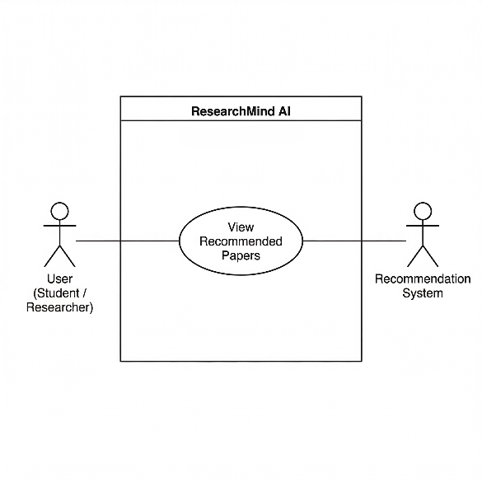
2.1.5 Add Paper to Workspace
Description:
This use case allows the user to save a selected research paper into their personal workspace for future access.
Actor:
User
Precondition:
The user must be logged in and have selected a paper.
Basic Flow:
- The user selects the option to save the paper.
- The system stores the selected paper in the user’s workspace.
- The workspace is updated accordingly.
Postcondition:
The selected paper is added to the user’s saved collection.
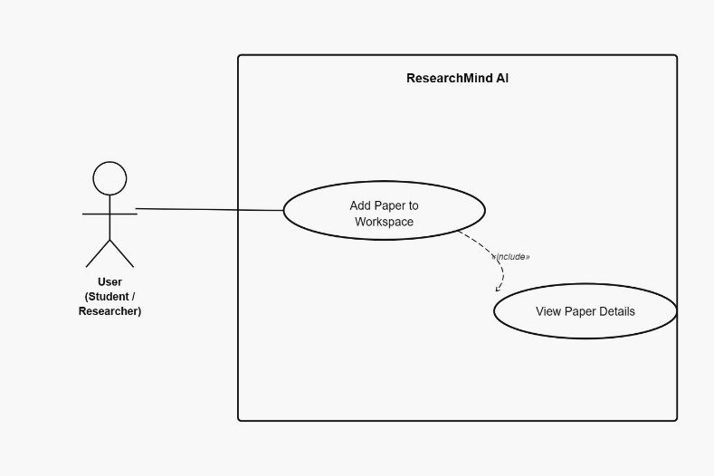
2.1.6 Manage Notes
Description:
This use case allows the user to create, edit, or delete notes related to a research paper.
Actor:
User
Precondition:
The user must have at least one saved or opened paper.
Basic Flow:
- The user opens a paper.
- The user writes or edits notes related to the paper.
- The system stores the notes in the database.
- The user may update or delete notes later.
Postcondition:
Notes are successfully managed and linked to the corresponding paper.
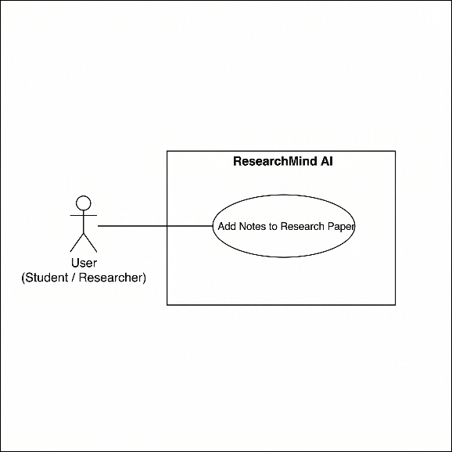
2.1.7 Track Reading Progress
Description:
This use case allows the user to monitor and update the reading status of saved research papers.
Actor:
User
Precondition:
The user must have papers in the workspace.
Basic Flow:
- The user opens the workspace or reading tracker section.
- The user marks a paper as unread, in progress, or completed.
- The system updates the progress status in the database.
- The updated reading status is displayed.
Postcondition:
The reading progress of the selected paper is updated.
2.1.8 View Recommended Papers
Description:
This use case allows the user to receive recommendations for relevant research papers based on interests, saved papers, or activity.
Actor:
User
Precondition:
The user must be logged in.
Basic Flow:
- The system analyzes the user’s saved papers or interests.
- The system generates suitable recommendations.
- Recommended research papers are displayed to the user.
- The user may open or save any recommended paper.
Postcondition:
Relevant recommended papers are displayed to the user.
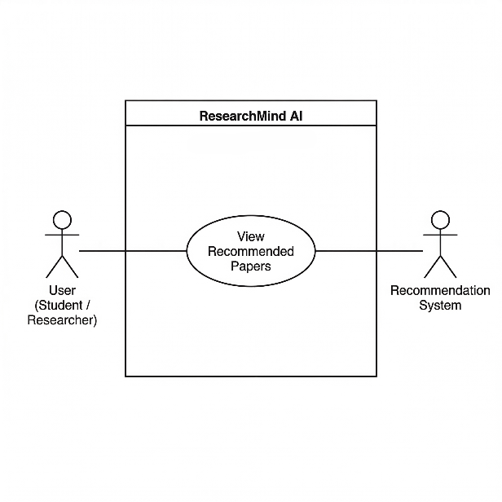
2.1.9 Generate AI Summary
Description:
This use case allows the user to obtain an AI-generated summary of a selected research paper.
Actor:
User
Precondition:
The user must select a paper.
Basic Flow:
- The user opens a research paper.
- The user selects the summary generation option.
- The system processes the paper content using AI functionality.
- A concise summary is generated and displayed.
Postcondition:
An AI-generated summary is shown for the selected paper.
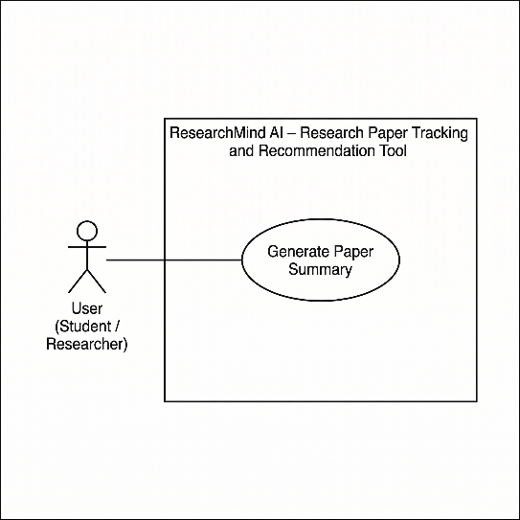

3. Design Overview
The Design Overview of the Research Paper Tracking System presents a high-level description of the system architecture and design approach. It explains how the system is structured into different modules, how these modules interact, and how the overall system fulfills the requirements specified in the Software Requirements Specification (SRS).
The system follows a modular and layered architecture, separating the user interface, application logic, and data management components. This design ensures scalability, maintainability, and ease of integration with external services such as APIs and AI-based functionalities.
The design emphasizes clear module separation, efficient data handling, and smooth interaction between components to provide a seamless user experience.
3.1 Design Goals and Constraints
Design Goals
The primary goals of the system design are:
- Modularity:
The system is divided into independent modules such as authentication, search, workspace, notes, and recommendation to ensure maintainability.
- Scalability:
The system is designed to handle increasing numbers of users and research papers efficiently.
- Usability:
A simple and intuitive user interface is provided to enhance user experience.
- Performance:
Efficient data retrieval and processing mechanisms are used to ensure fast response times.
- Security:
User data and authentication details are protected using secure practices.
- Extensibility:
The system design allows easy integration of new features such as advanced AI recommendations.
Constraints
- The system is developed within academic project timelines.
- Limited computational resources may affect performance optimization.
- The system depends on external APIs or datasets for research paper retrieval.
- AI-based features depend on availability and response time of external services.
- The design must remain simple and understandable for academic evaluation.
3.2 Design Assumptions
The following assumptions are made during the design of the system:
- Users have basic knowledge of web applications.
- A stable internet connection is available for accessing research papers and external APIs.
- External services such as research paper databases and AI tools are available and functional.
- The system will be accessed through standard web browsers.
- The database will store user data, saved papers, and notes reliably.
- The number of users will remain within manageable limits for an academic project.
3.3 Significant Design Packages
The system is divided into the following major design packages (modules):
- User Interface Package:
Handles all front-end interactions, including user input, navigation, and display of results.
- Authentication Module:
Manages user registration, login, and session handling.
- Search Module:
Handles searching of research papers using keywords, titles, or authors.
- Paper Management Module:
Manages viewing of paper details and storing paper metadata.
- Workspace Module:
Allows users to save, organize, and manage selected research papers.
- Notes Management Module:
Enables users to create, update, and delete notes associated with research papers.
- Progress Tracking Module:
Tracks the reading status of papers (e.g., unread, in progress, completed).
- Recommendation Module:
Provides suggestions based on user preferences and saved papers.
- AI Integration Module:
Handles AI-based functionalities such as summary generation.
- Database Layer:
Manages data storage, retrieval, and updates for users, papers, and notes.
These packages are designed to work independently while interacting through well-defined interfaces.
3.4 Dependent External Interfaces
The system depends on several external interfaces for its functionality. These interfaces are used by different modules to perform specific tasks.
External Application / Interface | Module Using the Interface | Functionality / Description
Research Paper API (e.g., Semantic Scholar / arXiv) | Search Module | Retrieves research paper data based on user queries
AI Service API (LLM-based) | AI Integration Module | Generates summaries of research papers
Authentication Service (if external) | Authentication Module | Validates user credentials and manages authentication
Web Browser Interface | User Interface Module | Allows users to interact with the system

3.5 Implemented Application External Interfaces
The system also provides interfaces that can be used internally or extended for future integration.

Interface Name | Module Implementing the Interface | Functionality / Description
User Authentication API | Authentication Module | Handles user login, registration, and validation
Search API | Search Module | Processes search queries and returns paper results
Workspace API | Workspace Module | Manages saving and retrieving user-selected papers
Notes API | Notes Management Module | Handles creation, update, and deletion of notes
Progress Tracking API | Progress Module | Updates and retrieves reading progress
AI Summary API | AI Integration Module | Generates summaries for selected papers

4. Logical View
The Logical View of the Research Paper Tracking System describes the internal structure of the software in terms of modules, logical layers, and their interactions. It explains how the major components of the system collaborate to perform the required functionalities identified in the use case view.
The system is designed using a layered and modular approach to improve maintainability, readability, and extensibility. Each layer has a specific responsibility, and together they ensure smooth data flow and functionality execution.
The logical design consists of the following major layers:
- Presentation Layer:
Handles user interaction through the graphical user interface, forms, dashboards, and result displays.
- Application / Business Logic Layer:
Contains the core system logic responsible for authentication, search processing, note management, workspace handling, recommendation generation, and AI summary requests.
- Data Access Layer:
Manages communication between the application logic and the database, including storing and retrieving user data, paper data, notes, and progress records.
- External Service Layer:
Handles communication with external APIs such as research paper retrieval services and AI-based summarization tools.
These layers work together to realize the required use cases efficiently.
4.1 Design Model
The design model of the Research Paper Tracking System is divided into several functional modules, each responsible for a specific part of the system. These modules interact logically to implement the complete application behaviour.
Class diagram:
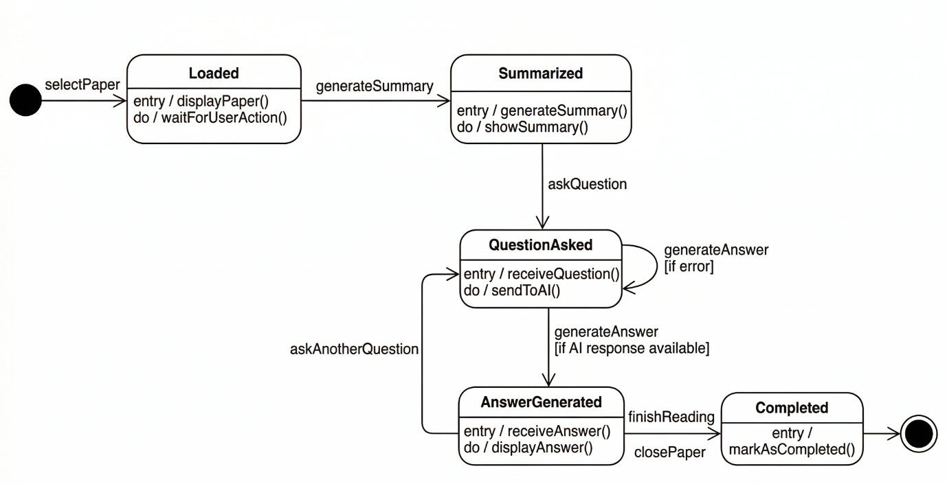
Major Modules in the Design Model
1. User Module
Responsible for handling user-related operations such as registration, login, and profile access.
Main Responsibilities:
- Register user accounts
- Authenticate users
- Manage user sessions
Important Attributes:
- User ID
- Name
- Email
- Password
2. Search Module
Responsible for processing user search queries and retrieving relevant research papers.
Main Responsibilities:
- Accept search keywords
- Fetch relevant papers
- Display search results
Important Attributes:
- Search Query
- Paper Title
- Author Name
- Keywords
3. Paper Module
Responsible for handling the details of research papers.
Main Responsibilities:
- Display paper metadata
- Provide abstract and details
- Connect papers to workspace and notes
Important Attributes:
- Paper ID
- Title
- Authors
- Abstract
- Publication Year
- Source
4. Workspace Module
Responsible for managing papers saved by the user.
Main Responsibilities:
- Save selected papers
- Organize workspace
- Retrieve stored papers
Important Attributes:
- Workspace ID
- User ID
- Saved Paper List
5. Notes Module
Responsible for note-taking and note management for research papers.
Main Responsibilities:
- Add notes
- Edit notes
- Delete notes
- Link notes to specific papers
Important Attributes:
- Note ID
- Paper ID
- User ID
- Note Content
6. Progress Tracking Module
Responsible for tracking the reading progress of each saved paper.
Main Responsibilities:
- Mark papers as unread, in progress, or completed
- Update progress status
- Display reading progress
Important Attributes:
- Progress ID
- User ID
- Paper ID
- Status
7. Recommendation Module
Responsible for generating recommended research papers for the user.
Main Responsibilities:
- Analyze saved papers or user interests
- Generate recommendations
- Display suggested papers
Important Attributes:
- Recommendation ID
- User ID
- Recommended Paper List
8. AI Summary Module
Responsible for generating summaries of selected research papers.
Main Responsibilities:
- Receive selected paper content
- Process summary request
- Display AI-generated summary
Important Attributes:
- Summary ID
- Paper ID
- Generated Summary
Relationships Between Modules
The modules in the system are logically connected as follows:
- The User Module controls access to all other modules.
- The Search Module retrieves papers which are passed to the Paper Module.
- The Paper Module interacts with the Workspace Module, Notes Module, and AI Summary Module.
- The Workspace Module connects with the Progress Tracking Module to update reading status.
- The Recommendation Module uses user activity and saved papers for generating suggestions.
This modular design helps in maintaining clear separation of responsibilities and improves system organization.

4.2 Use Case Realization
This section explains how the major use cases identified in Section 2 are realized within the system design. Each use case is implemented through interaction among multiple modules.
Activity diagram:
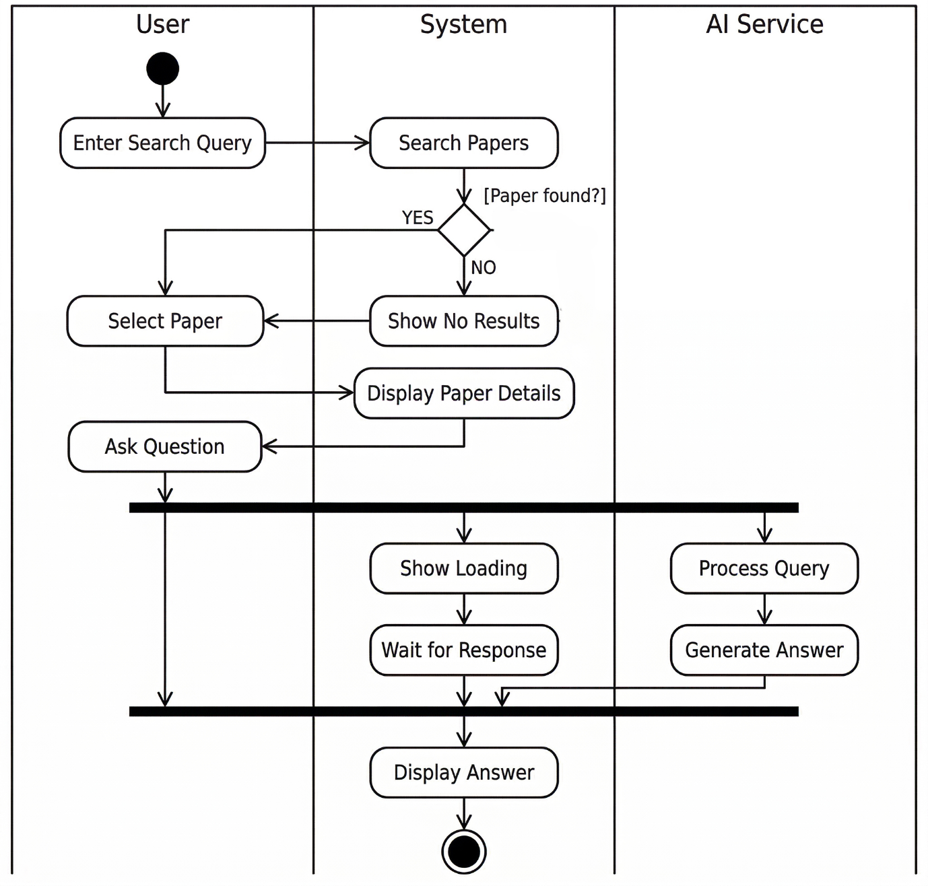

Component diagram:
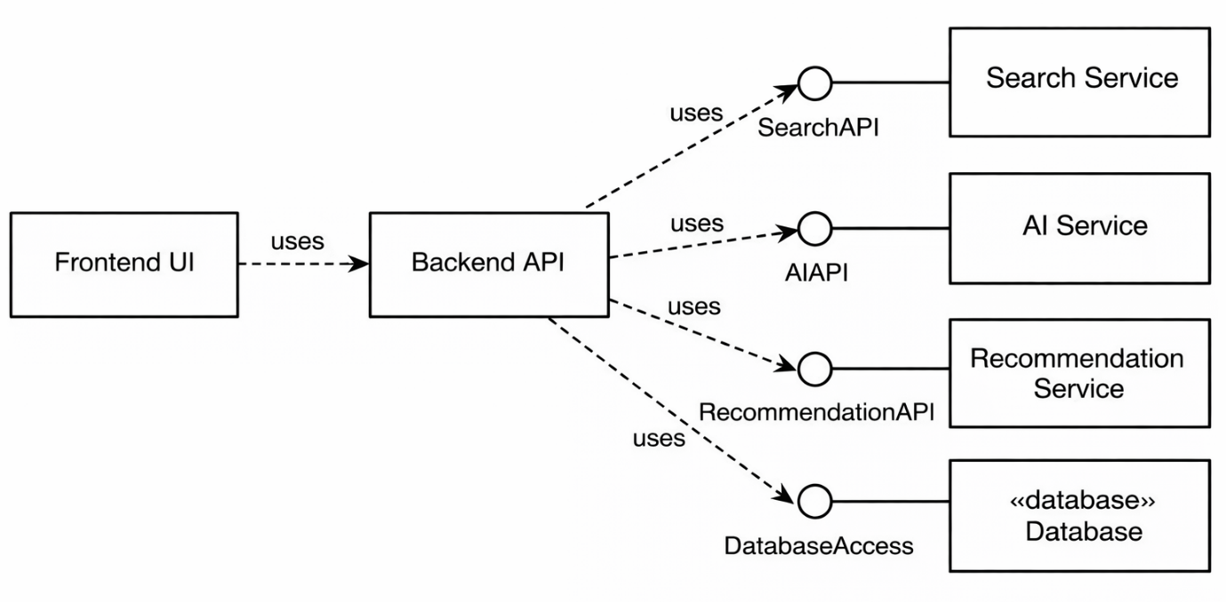
4.2.1 Register Account
Modules Involved:
User Interface Module, Authentication Module, Database Layer
Realization:
The user enters registration details through the interface. The Authentication Module validates the input and stores the new user information in the database. Once the registration is successful, the user is allowed to log in.
4.2.2 Login to the System
Modules Involved:
User Interface Module, Authentication Module, Database Layer
Realization:
The user enters login credentials through the interface. The Authentication Module checks the entered credentials against stored user data in the database. If the details are valid, the system grants access to the dashboard.
4.2.3 Search Research Papers
Modules Involved:
User Interface Module, Search Module, External Paper API, Paper Module
Realization:
The user submits a search query. The Search Module sends the request to the external paper retrieval service. The results are processed and displayed through the user interface. Selected papers are passed to the Paper Module for detailed viewing.
4.2.4 View Paper Details
Modules Involved:
Paper Module, User Interface Module
Realization:
When a user selects a paper, the Paper Module fetches and displays detailed metadata such as title, abstract, authors, and source. This information is shown on the paper details page.
4.2.5 Add Paper to Workspace
Modules Involved:
Paper Module, Workspace Module, Database Layer
Realization:
When the user selects the save option, the Workspace Module stores the selected paper information in the user’s workspace in the database. The paper is then available for future access.
4.2.6 Manage Notes
Modules Involved:
Notes Module, Paper Module, Database Layer
Realization:
The user creates, edits, or deletes notes for a selected paper. The Notes Module manages these actions and stores the notes in the database linked to the appropriate paper and user.
4.2.7 Track Reading Progress
Modules Involved:
Workspace Module, Progress Tracking Module, Database Layer
Realization:
The user updates the reading status of a saved paper. The Progress Tracking Module records the selected status and updates the corresponding entry in the database.
4.2.8 View Recommended Papers
Modules Involved:
Recommendation Module, Workspace Module, Search Module
Realization:
The Recommendation Module analyses user activity, saved papers, or selected interests and generates suitable paper recommendations. These are then displayed to the user.
4.2.9 Generate AI Summary
Modules Involved:
Paper Module, AI Summary Module, External AI Service
Realization:
The user requests a summary for a selected paper. The AI Summary Module sends the paper content or abstract to the external AI service, receives the generated summary, and displays it to the user.

5. Data View
The Data View of the Research Paper Tracking System describes how persistent data is stored, managed, and related within the system. It defines the major data entities used in the application, the relationships among them, and the structure of stored information required to support the system functionalities.
The system stores user-related information, research paper metadata, workspace details, notes, reading progress, and AI-generated summaries. The data view ensures that the system can efficiently retrieve, update, and manage information while maintaining consistency and organization.
5.1 Domain Model
The domain model represents the main entities involved in the Research Paper Tracking System and the relationships between them. These entities form the core data structure of the application.
Main Domain Entities
1. User
Represents a registered user of the system.
Attributes:
- User_ID
- Name
- Email
- Password
2. Research_Paper
Represents a research paper available in the system.
Attributes:
- Paper_ID
- Title
- Authors
- Abstract
- Publication_Year
- Keywords
- Source
3. Workspace
Represents the collection of papers saved by a user.
Attributes:
- Workspace_ID
- User_ID
4. Saved_Paper
Represents the relationship between a workspace and saved research papers.
Attributes:
- SavedPaper_ID
- Workspace_ID
- Paper_ID
- Saved_Date
5. Note
Represents user-created notes for a specific research paper.
Attributes:
- Note_ID
- User_ID
- Paper_ID
- Note_Content
- Created_Date
6. Progress
Represents the reading status of a research paper for a user.
Attributes:
- Progress_ID
- User_ID
- Paper_ID
- Status
7. Recommendation
Represents recommended research papers shown to the user.
Attributes:
- Recommendation_ID
- User_ID
- Paper_ID
- Recommendation_Date
8. AI_Summary
Represents an AI-generated summary for a research paper.
Attributes:
- Summary_ID
- Paper_ID
- Summary_Text
- Generated_Date
Relationships Between Entities
The domain model includes the following major relationships:
- One User can have one Workspace
- One User can create many Notes
- One User can have many Progress records
- One Workspace can contain many Saved_Papers
- One Research_Paper can have many Notes
- One Research_Paper can have one or more AI_Summaries
- One Research_Paper can appear in many Recommendations
- One Research_Paper can appear in many Saved_Papers
These relationships define how data is logically organized in the system.
5.2 Data Model (Persistent Data View)
The persistent data model describes how the domain entities are stored in the database as tables. Each entity corresponds to a database table with primary keys and foreign key relationships.
Main Database Tables
- Users
- Research_Papers
- Workspaces
- Saved_Papers
- Notes
- Progress
- Recommendations
- AI_Summaries
This data model ensures that the system can support:
- user account management
- paper retrieval and storage
- note-taking
- reading progress tracking
- AI summary generation
- recommendation functionality
The database design follows a structured relational approach to maintain consistency and avoid redundant data.
5.2.1 Data Dictionary
The data dictionary defines the key fields stored in each table of the system database.
Table: Users
Field Name | Data Type | Description
User_ID | Integer | Unique identifier for the user
Name | Varchar | Name of the user
Email | Varchar | Email address of the user
Password | Varchar | Encrypted password of the user

Table: Research_Papers
Field Name | Data Type | Description
Paper_ID | Integer | Unique identifier for the paper
Title | Varchar | Title of the research paper
Authors | Varchar | Name(s) of the author(s)
Abstract | Text | Summary/abstract of the paper
Publication_Year | Integer | Year of publication
Keywords | Varchar | Keywords related to the paper
Source | Varchar | Source or database of the paper

Table: Workspaces
Field Name | Data Type | Description
Workspace_ID | Integer | Unique identifier for the workspace
User_ID | Integer | Foreign key linking to user

Table: Saved_Papers
Field Name | Data Type | Description
SavedPaper_ID | Integer | Unique identifier for saved paper entry
Workspace_ID | Integer | Foreign key linking to workspace
Paper_ID | Integer | Foreign key linking to research paper
Saved_Date | Date | Date on which the paper was saved

Table: Notes
Field Name | Data Type | Description
Note_ID | Integer | Unique identifier for the note
User_ID | Integer | Foreign key linking to user
Paper_ID | Integer | Foreign key linking to paper
Note_Content | Text | User-written note content
Created_Date | Date | Date of note creation

Table: Progress
Field Name | Data Type | Description
Progress_ID | Integer | Unique identifier for progress record
User_ID | Integer | Foreign key linking to user
Paper_ID | Integer | Foreign key linking to paper
Status | Varchar | Reading status (Unread / In Progress / Completed)

Table: Recommendations
Field Name | Data Type | Description
Recommendation_ID | Integer | Unique identifier for recommendation
User_ID | Integer | Foreign key linking to user
Paper_ID | Integer | Foreign key linking to paper
Recommendation_Date | Date | Date recommendation was generated

Table: AI_Summaries
Field Name | Data Type | Description
Summary_ID | Integer | Unique identifier for summary
Paper_ID | Integer | Foreign key linking to paper
Summary_Text | Text | AI-generated summary content
Generated_Date | Date | Date summary was generated

6. Exception Handling
Exception handling in the Research Paper Tracking System is designed to ensure that unexpected errors and abnormal situations are managed properly without causing system failure or poor user experience. The system handles exceptions gracefully by validating inputs, displaying meaningful error messages, logging technical issues, and maintaining data consistency wherever possible.
The objective of exception handling is to improve system reliability, prevent data loss, and assist developers in debugging and maintenance.
6.1 Types of Exceptions
The following exceptions may occur in the system:
1. Invalid Login Credentials
Occurs when a user enters an incorrect email or password during login.
Handling:
The system displays an appropriate error message such as “Invalid email or password” and allows the user to retry.
2. Registration Validation Errors
Occurs when a user enters incomplete, duplicate, or invalid registration details.
Handling:
The system validates the input and displays messages such as “Email already exists” or “Please fill all required fields”.
3. Empty or Invalid Search Query
Occurs when the user submits an empty or unsupported search request.
Handling:
The system prompts the user to enter a valid keyword, title, or author name before proceeding.
4. No Search Results Found
Occurs when no research papers match the entered query.
Handling:
The system displays a message such as “No matching research papers found” without interrupting user activity.
5. External API Failure
Occurs when the system is unable to retrieve research papers or AI-generated summaries due to external API issues or network problems.
Handling:
The system displays a message such as “Service temporarily unavailable. Please try again later”. The request may be retried if applicable.
6. Database Access Errors
Occurs when the system fails to store or retrieve information from the database.
Handling:
The system prevents incomplete transactions, shows a generic error message to the user, and logs the issue for debugging.
7. Unauthorized Access
Occurs when an unauthenticated user tries to access restricted system features.
Handling:
The system redirects the user to the login page or denies access with an appropriate message.
8. Note Save or Update Failure
Occurs when notes cannot be stored or updated properly.
Handling:
The system informs the user that the note could not be saved and allows retrying the action.
9. Progress Update Failure
Occurs when the reading progress status cannot be updated due to a system or database issue.
Handling:
The system displays an error message and prevents invalid or partial updates.

6.2 Exception Logging
All major system exceptions are recorded using logging mechanisms to help identify and debug technical issues. Logged exceptions may include:
- Database connection failures
- API communication errors
- Server-side processing failures
- Unexpected runtime exceptions
The logs may contain:
- Date and time of error
- Module or component where the error occurred
- Type of exception
- Brief technical description of the issue
This logging process supports maintenance and troubleshooting.
6.3 User Notification and Recovery
Whenever an exception occurs, the system provides a user-friendly message instead of exposing technical details. This ensures usability and security.
Recovery actions may include:
- Re-entering user input
- Retrying failed operations
- Redirecting to login page
- Refreshing or reloading data
- Preventing invalid transactions
The system is designed to continue operating wherever possible, even when non-critical exceptions occur.

7. Configurable Parameters
The Research Paper Tracking System includes several configurable parameters that control system behaviour and improve flexibility. These parameters allow the application to adapt to different operational needs without requiring major changes in the source code.
Configurable parameters are used to manage system settings related to user sessions, search functionality, AI-based summarization, recommendations, and external service integration. Some parameters can be changed dynamically, while others may require restarting or redeploying the application.
The following table describes the major configurable parameters used in the system.
7.1 Configurable Parameters Table
Configuration Parameter Name | Definition and Usage | Dynamic?
MAX_SEARCH_RESULTS | Defines the maximum number of research papers displayed for a single search query | Yes
SESSION_TIMEOUT | Specifies the duration for which a user session remains active after login | Yes
AI_SUMMARY_LENGTH | Controls the approximate length of the AI-generated summary | Yes
RECOMMENDATION_LIMIT | Defines the maximum number of recommended papers shown to the user | Yes
API_REQUEST_TIMEOUT | Specifies the maximum waiting time for external API responses | No
DATABASE_CONNECTION_STRING | Stores the database connection details required by the system | No
PAPER_SOURCE_API_URL | Defines the external API endpoint used to fetch research papers | No
AI_SERVICE_API_URL | Defines the external AI service endpoint used for summary generation | No
NOTE_CHARACTER_LIMIT | Specifies the maximum number of characters allowed in user notes | Yes
ALLOWED_FILE_FORMATS (if file upload exists) | Defines the allowed file types supported by the system | Yes
DEFAULT_PROGRESS_STATUS | Sets the default reading status for newly saved papers | Yes

7.2 Parameter Usage
These configurable parameters are used to support system flexibility and maintainability. For example:
- Search-related parameters help control the amount of data shown to users.
- Session settings improve security and access control.
- AI-related parameters control summary behavior and external service usage.
- API and database settings ensure proper communication with external systems.
- Note and progress settings help standardize user interactions.
These configurations allow the system to be adjusted easily for future enhancements or deployment requirements.
7.3 Dynamic and Static Parameters
The configurable parameters in the system are categorized as:
Dynamic Parameters
These can be modified without major changes to the application logic and may be updated during runtime or through configuration settings.
Examples:
- MAX_SEARCH_RESULTS
- AI_SUMMARY_LENGTH
- RECOMMENDATION_LIMIT
- NOTE_CHARACTER_LIMIT
- DEFAULT_PROGRESS_STATUS
Static Parameters
These are generally fixed during deployment and usually require restarting or reconfiguring the application if changed.
Examples:
- DATABASE_CONNECTION_STRING
- PAPER_SOURCE_API_URL
- AI_SERVICE_API_URL
- API_REQUEST_TIMEOUT
8. Quality of Service
The Quality of Service section describes the non-functional quality aspects of the Research Paper Tracking System, including availability, security, performance, and monitoring. These qualities are important to ensure that the system remains reliable, secure, efficient, and maintainable during operation.
The design of the system considers these service quality aspects to provide a smooth user experience and stable software behaviour.
8.1 Availability
The Research Paper Tracking System is designed to be available to users whenever needed through a web-based interface. Since the system is intended as an academic software application, it is expected to provide reliable access under normal usage conditions.
The following design aspects support availability:
- The system uses a modular architecture to reduce failure impact.
- Core functionalities such as login, paper search, workspace access, and note management are designed to remain operational independently where possible.
- Database storage ensures persistent access to user data and saved papers.
- External service failures, such as research paper API or AI summary service interruptions, are handled gracefully without causing complete system failure.
- Maintenance or updates can be performed with minimal impact on core system functions.
Although continuous 24/7 enterprise-level availability is not required for this academic project, the design aims to ensure stable and consistent access for users.
8.2 Security and Authorization
Security and authorization are essential for protecting user accounts, stored research data, notes, and personalized workspace content. The system includes basic security measures to ensure safe access and controlled usage.
The following design considerations support security and authorization:
- User Authentication:
Only registered users can log in and access protected system features.
- Credential Validation:
Login details are validated before granting access.
- Session Control:
User sessions are maintained securely and can expire after inactivity.
- Access Restriction:
Unauthorized users are restricted from accessing private data such as saved papers, notes, and progress records.
- Input Validation:
User inputs such as registration data, notes, and search queries are validated to reduce the risk of invalid or harmful input.
- Data Protection:
Sensitive data such as passwords should be stored securely using appropriate encryption or hashing mechanisms.
These measures ensure that the system provides a secure environment for users and their research management activities.
8.3 Load and Performance Implications
The system is designed to provide acceptable performance under expected academic usage conditions. Since the application involves searching, retrieving, and managing research paper information, performance considerations are important for maintaining responsiveness and usability.
The following design aspects support performance:
- Search operations are designed to retrieve relevant results efficiently.
- Frequently accessed user data such as saved papers and notes can be loaded quickly from the database.
- The modular design helps isolate processing tasks and reduce unnecessary delays.
- AI summary generation and external API calls are treated as separate service operations to avoid blocking the overall user interface.
- Database queries are structured to support efficient storage and retrieval.
Expected Load Assumptions
The system is expected to handle:
- A moderate number of concurrent users typical of an academic project
- User operations such as login, paper search, note creation, and progress tracking
- Controlled API requests for research paper retrieval and AI-based summaries
Under these assumptions, the system is expected to provide satisfactory performance for normal use.
8.4 Monitoring and Control
Monitoring and control help ensure that the system can be observed, managed, and maintained effectively during operation. The Research Paper Tracking System includes basic monitoring and control mechanisms to support error handling and performance observation.
The following aspects are considered:
- Error Logging:
Important system exceptions such as API failures, database errors, and login issues are logged for debugging and maintenance.
- Activity Monitoring:
Key user actions such as login attempts, paper saving, note creation, and progress updates may be monitored internally.
- System Health Observation:
External service responses and database connectivity can be checked to ensure proper operation.
- Administrative Control:
Basic configuration parameters and system settings can be adjusted as needed to support maintenance and usage control.
- Recovery Support:
Logged information can be used to identify failures and improve recovery or debugging efforts.
These monitoring and control mechanisms improve the maintainability and reliability of the system.

